KnowNoticeWonder |  | Name: | Date:
KNOW | NOTICE |  | WONDER
Whatdoyoualreadyknow? | Whatdoyounotice? |  | Whatdoesitmakeyouwonder?

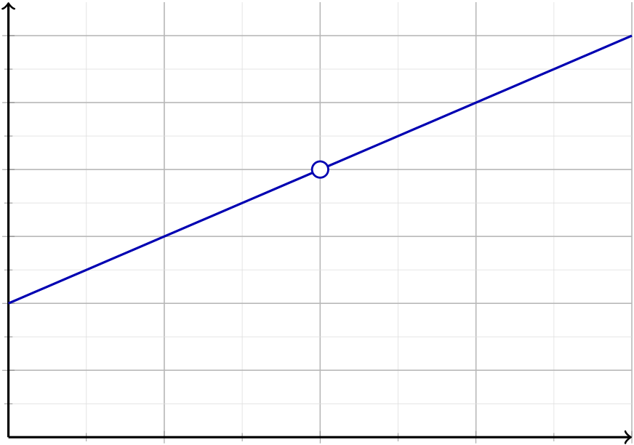
ClosingIn | Groupmembers:
Worktogether.Forf(x) =x2 −4 x −2,llinf(x)asxgetscloserandcloserto2oncefromtheleft(startingat1)
andoncefromtheright(startingat3).Theblankrowsineachtableareyours:pickanxthatisevencloserto2
thantheseededvalues,thencomputef(x).Whatvaluearetheoutputsclosinginonandwhathappensatx = 2 itself?
y
6
5
(2,?)
4
3
2
1
1 | 2 | 3 | x  4

Fromtheleft(startat1,lldownto2)
x | f(x)
1
1.5
1.9

Fromtheright(startat3,lldownto2)
x | f(x)
3
2.5
2.1

1.Whatisf(2)?Compute(2)2 −4 2 −2. Whydoesyourcalculatordothis?
2.Bothtablescloseinonthesamevalue.Asxgetscloserandcloserto2fromeitherside,whatvaluedo
theoutputsf(x)closeinon?
3.Lookatthepoint(2,?)onthegraph.Inonesentence,saybothwhatthefunctiondoesatx = 2and
whattheoutputsdoasxclosesinon2.

NametheMethod | Groupmembers:
InClosingInyoufoundthesinglevaluethatf(x)washeadingtowardasxgotcloserandcloserto2withoutever
usingx = 2itself.Thepointofmathistodoitagain,foranyfunction.Sowritedownexactlywhatyourgroupdid,
stepbystep,thennameanddeneyourmethod.
Writethesteps.Thinkabout:whichx-valuesdidyouchoose?whatdidyoucomputeateach?howdidyoudecide
onthenalvalue?howdidyoumakesurebothsidesagreed?
Step1.
Step2.
Step3.
Step4.
Give your method a name.What would you call this process, so you could tell a friend just use the
method?
Deneyourmethod.Writeaone-sentencedenition,asifitweregoinginatextbook.Startwith:Tondthe
valueafunctionisheadingtowardasxgetsclosetoapoint,you . . .

Cutalongthelinesinto4slips.
1.Inyourownwords,whatdoesitmeanthattheout-putsheadtoward4?  2.How can the function head toward 4 near x = 2 when ithasnovalueatx = 2? | 1.Inyourownwords,whatdoesitmeanthattheout-putsheadtoward4?  2.How can the function head toward 4 near x = 2 when ithasnovalueatx = 2?
   2.2ExitTicket | Name:
  For f(x) =x2 −4 x −2:as x closes in on 2, the outputs head
  toward 4 yet the calculator shows ERROR at x = 2.
   2.2ExitTicket | Name:
  For f(x) =x2 −4 x −2:as x closes in on 2, the outputs head
  toward 4 yet the calculator shows ERROR at x = 2.
1.Inyourownwords,whatdoesitmeanthattheout-putsheadtoward4?  2.How can the function head toward 4 near x = 2 when ithasnovalueatx = 2? | 1.Inyourownwords,whatdoesitmeanthattheout-putsheadtoward4?  2.How can the function head toward 4 near x = 2 when ithasnovalueatx = 2?
   2.2ExitTicket | Name:
  For f(x) =x2 −4 x −2:as x closes in on 2, the outputs head
  toward 4 yet the calculator shows ERROR at x = 2.
   2.2ExitTicket | Name:
  For f(x) =x2 −4 x −2:as x closes in on 2, the outputs head
  toward 4 yet the calculator shows ERROR at x = 2.

